

Project Title: YCSpout (You Can Speak Out): A Digital Public Speaking Platform for Rural Students in Rwanda

BSc. in Software Engineering

Names: Noella UWAYO

Task One: The ethical considerations raised by my research proposal and how I plan to address them
My research proposal, titled "YCSpout,” A Digital Public Speaking Platform for Rural Students in Rwanda, aiming to support remote learners in improving their public expression skills in an easy and friendly way. The platform offers video tutorials and interactive tasks that guide students throughout the process. Upon completing each task, students receive personalized feedback to help track their progress and build confidence.

In developing the platform, ethical considerations will be addressed and carefully respected. As the platform is designed for children who belong to a vulnerable group therefore, it is more important to have their well-being, privacy, rights, and dignity protected. I have to seek ethical clearance from ALU’s ethical committee and obtain formal consent from school authorities, teachers, as well as their guardians before beginning any data collection or interaction with students. I also have to ensure that everyone involved understands the purpose of the project, what participation entails, and that they are free to opt out at any time without consequences.

Managing data securely and respectfully is another priority. All information collected, such as voice and video recordings and progress reports, will be stored in a secure folder or on my Google Drive account, which is another secure place with restricted access. To protect students’ identities during analysis and reporting, personal identifiable information will be anonymized. For example, instead of recording the students’ names, I will assign unique ID numbers to each participant involved in the survey. If feedback or performance samples are selected for use in presentations or publications, I will seek additional consent to ensure and maintain the privacy and confidentiality of participants.

Since the platform incorporates existing open source tools, code libraries, or speech training algorithms, I will credit all reused resources properly and follow licensing requirements, maintaining both integrity and compliance. From a design perspective, the platform’s tone and content will focus on encouragement, confidence-building, and individual growth. It will avoid language that could lead to negative self-labelling, such as “bad speaker,” and instead celebrate progress at each learner’s pace.

The project will further align with Rwanda’s digital and child protection laws, which allow children to use and access the digital environment while maintaining children’s safety and well-being (Innovation, 2019), as well as ALU’s research ethics framework. The ultimate goal is to create a safe, inclusive, and positive learning experience, which not only teaches speaking skills but also empowers young learners to express themselves with confidence.

Task Two: How I will integrate ethical morals and professional conduct into my capstone project proposal.
This section describes how ethical principles will be applied in making decisions during the development of my project. It includes a clear project plan and timeline visualized through a Gantt chart, discussion of key stakeholders and how they might be impacted, as well as the ethical frameworks, both local and international, that will guide my actions and choices during the research and development process.

My project plan and timeline are well explained in this Gantt chart.
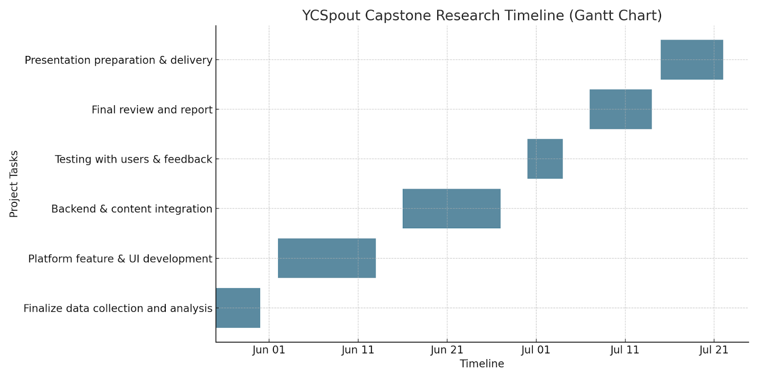
Figure 1: Gantt chart of my project

Stakeholder Impact
The primary stakeholders in this project are students, particularly from underserved rural schools, who will directly benefit from the platform. This platform places special emphasis on students in upper primary school in rural areas. The students will have the opportunity to enhance their public speaking skills at different levels and receive personal feedback from various volunteer facilitators.
Teachers and school administrators are other stakeholders. They will assist in supervising students during the data collection process since the target students belong to a valuable group. Additionally, they will provide me with permission to conduct research in the school. They also stand to benefit because their students will gain access to a platform that promotes self-expression in a simple and accessible way. As a result, the school will be producing students who are better prepared to face the challenges of today’s technology-driven world.

Ethical Frameworks and Integration
To guide the research ethically, I have to follow a combination of local and international ethical standards.

ALU Research Ethics Framework. This framework serves as the foundation for obtaining ethical clearance. It emphasizes informed consent, beneficence, and minimizing harm (Manager et al., n.d.), principles that are critical when working with children. By developing the project and collecting data, I have to seek ethical approval through the official ALU research committee, using their forms and policies. Students will give assent in age-appropriate ways, while teachers, as their guardians, have to provide formal consent.

Rwanda’s Data Protection and Privacy Law (Law No. 058/2021 of 13/10/2021). This local law ensures that all personal data, especially from children, is protected (Data Protection and Privacy Office (DPPO), 2024). So I will avoid collecting sensitive information unless necessary. Any student records or feedback will be stored securely, anonymized where possible, and used solely for educational improvement. Students will be free to withdraw at any moment.

UNESCO's Universal Declaration on Bioethics and Human Rights (2005). The international ethical standard that promotes human dignity, non-discrimination, and respect for personal identity (UNESCO, 2006). These principles are especially meaningful to me when working with or supporting vulnerable young people. In practice, this means YCSpout will avoid ranking students or labeling their performance, and instead develop self-confidence through personalized feedback.

The Belmont Report (U.S. Department of Health and Human Services, 1979). The principles of Respect for Persons, Beneficence, and Justice from the Belmont Report (The Belmont Report | Human Subjects Office - Office of the Vice President for Research | The University of Iowa, n.d.) will be applied. In the context of YCSpout, that means that equal access to the platform should be available to all students regardless of gender, ability, and socioeconomic status, and avoiding engagement that would disadvantage a subgroup.

European Union General Data Protection Regulation (GDPR). The GDPR concepts, such as data minimization, the right to access, and purpose limitation (European Parliament & Council, 2016), are applied voluntarily in this project to uphold best practices in digital ethics and transparency.

By identifying stakeholder needs, anticipating ethical concerns, and applying recognized ethical frameworks, this project aims this project strives to create a secure, empowering, and respectful learning environment for its users. Ethical practice is not only a guide but a personal commitment I adhere to, especially while serving vulnerable groups like school children. Under these arrangements, the project is in the best position to make meaningful and positive change while maintaining the highest standards of integrity and professionalism.

References:
Data Protection and Privacy Office (DPPO). (2024, October 15). Data Protection & Privacy Office - DPP Law. https://dpo.gov.rw/dpp-law.html
European Parliament & Council. (2016). (EU) 2016/679 of the European Parliament and of the Council of 27 April 2016 on the protection of natural persons with regard to the processing of personal data and on the free movement of such data. In Official Journal of the European Union: Vol. L 119 (pp. 1–88).
Innovation, M. of I. and. (2019). Rwanda Child Online Protection Policy. June.
Manager, P., Date, C., Date, A., Revised, L., Date, N. R., Approved, P., & Senate, A. (n.d.). Policy and Procedure for Research Ethics.
The Belmont Report | Human Subjects Office - Office of the Vice President for Research | The University of Iowa. (n.d.). Retrieved June 12, 2025, from https://hso.research.uiowa.edu/about-human-subjects-office/regulations-and-policies/belmont-report
UNESCO. (2006). Universal Declaration on Bioethics and Human Rights - UNESCO Digital Library. https://unesdoc.unesco.org/ark:/48223/pf0000146180

