Chapter3 tutorials

- Explain the concept of a SCADA system and discuss its key components, emphasizing their roles in industrial automation.
A SCADA system, which stands for Supervisory Control and Data Acquisition, is a centralized control and monitoring system utilized in various industries to supervise and manage industrial processes and equipment remotely.
Its key components include:
- Remote Terminal Units (RTUs) and Programmable Logic Controllers (PLCs),
- communication networks,
- SCADA software,
- Human-Machine Interface (HMI),
- data storage and analysis systems,
- alarming and event logging mechanisms.
RTUs and PLCs collect data from sensors and devices, communication networks transmit this data, SCADA software processes and visualizes it, HMIs provide interfaces for operators, and data storage and analysis systems handle historical data for analysis and troubleshooting.
- Describe the architecture of a typical SCADA system, including the different levels and components involved. How are these components distributed within the system?
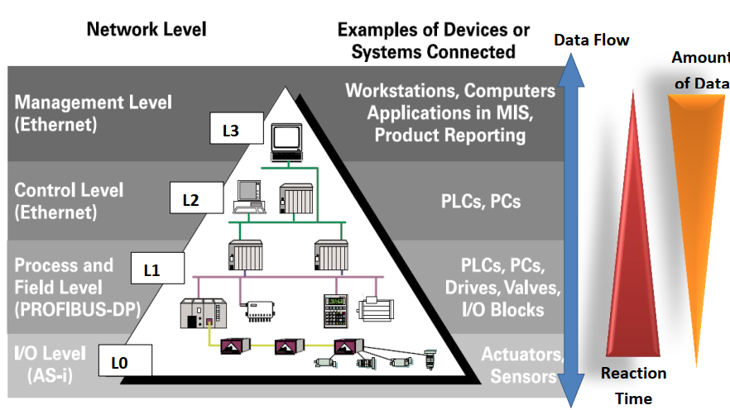
A typical SCADA system architecture consists of multiple levels: Level 0 (Input/Output), Level 1 (Process and Field), Level 2 (Control), Level 3 (Supervisory), and Level 4 (World Connection). Components such as sensors, actuators, RTUs, PLCs, PCs, and communication networks are distributed across these levels. Level 0 includes sensors and actuators, Level 1 gathers field values and commands, Level 2 comprises control devices like PLCs, Level 3 involves dynamic control, and Level 4 connects to the outside world using technologies like the internet.
- Discuss the purpose and key features of SCADA systems, focusing on real-time monitoring, data acquisition, and control operations.
The primary purpose of SCADA systems is to facilitate real-time monitoring, data acquisition, and control of industrial processes from a centralized location.
Key features include:
- real-time monitoring of process variables,
- data acquisition and storage,
- remote control operations,
- data visualization through HMIs,
- alarming and event logging,
- reporting and analysis,
- integration with other industrial automation components.

- Outline the benefits of implementing SCADA systems in industrial environments, highlighting their impact on productivity, efficiency, and cost savings.
Implementing SCADA systems in industrial environments offers several benefits, including:
- improved operational efficiency,
- enhanced productivity,
- increased profitability,
- reduced downtime,
- energy savings,
- streamlined troubleshooting and maintenance,
- real-time system monitoring,
- faster response to issues,
- scalability, reliability
- expansion capabilities.

- Explain the significance of communication protocols in SCADA systems. Compare and contrast commonly used protocols such as Modbus, DNP3, OPC, and Ethernet/IP.
Communication protocols are crucial in SCADA systems for exchanging data between components. Common protocols include Modbus (widely used, supports serial and Ethernet), DNP3 (for utility industry, offers advanced features), OPC (standard for interoperability), Ethernet/IP (utilizes standard Ethernet hardware), Profibus (supports high-speed communication), and others. Each protocol has its characteristics and suitability depending on the application requirements.
- Describe the methods and processes involved in data acquisition within SCADA systems, including polling, event-driven acquisition, and continuous monitoring.
Data acquisition in SCADA systems involves methods such as
- Polling: periodically querying field devices for data
- event-driven acquisition: transmitting data only when specific events occur)
- continuous monitoring: real-time streaming of data
These methods ensure timely collection of process variables and enable effective control and decision-making.
- Discuss how SCADA systems interface with sensors and actuators, addressing the types of signals used and the importance of signal conditioning.
SCADA systems interface with sensors and actuators using analog (e.g., 4-20 mA, 0-10 V) or digital signals. Signal conditioning may be necessary to convert sensor outputs into a format compatible with SCADA input modules. Effective interfacing ensures accurate data acquisition and control actions.
- Explain the role of SCADA software in system operation and management, detailing its features, functionalities, and vendor options available in the market.
- SCADA software plays a critical role in operation and management by providing tools for visualization, control, data acquisition, and analysis.
- Features include:
- visualization through GUIs
- control functionalities
- data acquisition methods
- alarm handling
- data logging and reporting
- security measures:
- development environments
- integration capabilities
- customization
- scalability
- user training and support.
- Vendor options include:
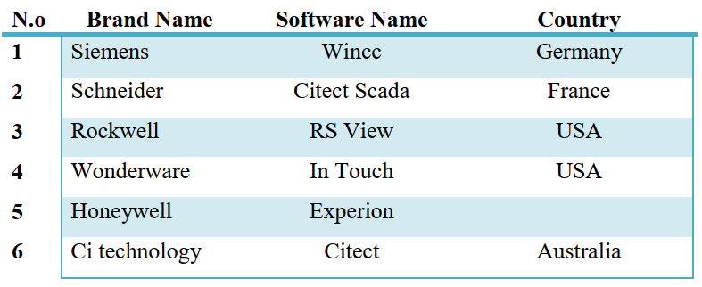
- Analyse the importance of security in SCADA systems, identifying common threats and vulnerabilities and discussing best practices for securing industrial assets.
Security is paramount in SCADA systems due to the critical nature of the processes they control.
Common threats include:
- cyberattacks,
- insider threats,
- vulnerabilities in legacy systems
- interconnected networks.
Best practices for security include:
- network segmentation
- access control
- encryption
- patch management
- monitoring and logging
- training and awareness programs
- regular security assessments
- penetration testing and compliance audits.

- Explore emerging trends and future directions in SCADA systems, such as cloud-based solutions, IoT integration, big data analytics, and sustainability initiatives, and discuss their potential impact on industrial automation.
Emerging trends in SCADA systems include:
- cloud-based solutions for scalability and accessibility
- IoT integration for real-time data collection and analysis
- big data analytics for predictive maintenance and operational optimization
- cybersecurity enhancements for protection against cyber threats
- edge computing for reduced latency and enhanced resilience,
- AI and ML for automation and performance improvement, and alignment
- Industry 4.0 principles and sustainability initiatives for increased efficiency and environmental conservation.
These trends are expected to shape the future of industrial automation by enabling smarter, more efficient, and sustainable processes.

Difference between SCADA and DCS

Architecture:
- SCADA systems typically use a centralized architecture, where all data is sent to a central host for processing and control decisions.
- DCS systems, on the other hand, use a distributed architecture, where control is distributed across multiple controllers and modules throughout the system.

Control:
- SCADA systems are primarily used for monitoring and control of a single site or process, often with remote access for operators.
- DCS systems are designed for controlling complex processes across multiple sites or areas within a single site, often with advanced control algorithms.
Scalability:
- SCADA systems are typically limited in their scalability and may require significant re-engineering to accommodate changes in the system.
- DCS systems are designed to be highly scalable, allowing for easy expansion and integration with other systems.
Processing Power:
- SCADA systems are generally less powerful and have lower processing capabilities compared to DCS systems.
- DCS systems are designed with more processing power, allowing for faster response times and more complex control algorithms.
Connectivity:
- SCADA systems are often designed to connect to a variety of equipment and devices using different protocols and technologies.
- DCS systems use standardized communication protocols and interfaces, allowing for seamless integration with other systems.
Security:
- SCADA systems are often less secure than DCS systems due to their use of multiple communication protocols and lack of standardization.
- DCS systems are designed with robust security features and standardized communication protocols to ensure secure operation.
Overall, SCADA and DCS systems are both used in industrial automation and control, but they are designed for different applications and environments. SCADA systems are typically used for monitoring and control of individual sites, while DCS systems are designed for more complex processes across multiple sites or areas.

Assignment 2
Title: Consider the topic title of your Final Year Project (Example: 5 water treatment sites Monitoring and Control System with SCADA Integration)
Objective: The objective of this assignment is to design and implement a comprehensive monitoring and control system for a remote stations or sites, integrating SCADA (Supervisory Control and Data Acquisition) technology with control systems, automation techniques, and communication technologies. Students will develop an architecture that enables remote monitoring, data acquisition, control, and visualization, addressing the challenges of limited infrastructure, human resources and connectivity in remote areas.
Project (Assignment) Description: The project involves designing and implementing a remote sites (RTUs) monitoring and control system with SCADA integration, aimed at managing environmental parameters, resources, and infrastructure remotely. Students will develop a scalable and adaptable solution that leverages SCADA technology for real-time monitoring, control, and data visualization in the remote area.
System Architecture: Develop a detailed architecture for the remote area monitoring and control system with SCADA integration, including the following components:
- Control Center: Centralized location housing the SCADA server and operator workstations for monitoring and control.
- Remote Terminal Units (RTUs): Deployed in the remote area to interface with sensors and actuators, collect data, and communicate with the SCADA server.
- SCADA Software: Software platform for data acquisition, HMI (Human-Machine Interface), alarming, trending, and reporting functionalities.
- Communication Infrastructure: Enables data transmission between the control center and remote RTUs, considering remote connectivity challenges.
- Data Storage and Analysis: Storage and analysis of collected data for historical reporting, trend analysis, and decision-making.
- User Interface: SCADA HMI for operators to monitor system status, receive alarms, acknowledge events, and initiate control actions remotely.
- Hardware and Sensors: Specify the hardware components required for the remote area monitoring and control system, including sensors for measuring environmental parameters such as temperature, humidity, air quality, water level, and energy consumption.
Select RTUs or PLCs (Programmable Logic Controllers) capable of interfacing with sensors and actuators, with communication capabilities compatible with SCADA protocols.
Communication Technologies: Explore communication technologies suitable for remote deployment, ensuring compatibility with SCADA protocols such as Modbus, DNP3, or OPC.
Evaluate options such as satellite communication, cellular networks, RF (Radio Frequency), or mesh networks for reliable data transmission between the control center and remote RTUs.
Control and Automation:
Implement remote control capabilities through the SCADA HMI to enable operators to adjust setpoints, activate/deactivate equipment, and execute predefined sequences remotely.
Project Documentation: Prepare comprehensive documentation covering the system architecture, hardware specifications, SCADA configuration, communication protocols, and deployment plan.
Presentation: Present the project architecture, SCADA integration, design considerations, implementation details, and deployment plan to peers, faculty members, and industry experts.
Demonstrate the functionality of the SCADA system through live simulations or recorded videos, showcasing real-time monitoring, control, and visualization capabilities.
This assignment challenges students to design and implement a remote area monitoring and control system with SCADA integration, providing hands-on experience in leveraging SCADA technology for remote management and automation. By integrating SCADA with control systems and communication technologies, students will develop a scalable and robust solution for monitoring and controlling remote areas efficiently and effectively.

